Science Week 6
Activity 1- What’s new in Space?
NASA & SpaceX are making history!
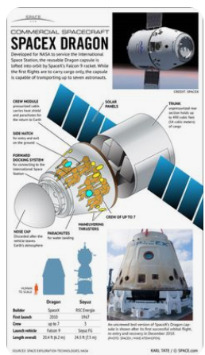
NASA and SpaceX are working toward a Wednesday May 27 launch date of a spacecraft called DRAGON. DRAGON will be the first free flying private aircraft that will carry supplies and astronauts Doug Hurley and Bob Behnken to and from the International Space Station (ISS).
Read a Washington Post article announcing the launch date of the Dragon spacecraft: https://www.washingtonpost.com/lifestyle/kidspost/nasaspacex-astronaut-launch-to-space-station-set-for-may-27/2020/04/19/3f206e44-82a2-11ea-878a-86477a724bdb_story.html

Check out some of the cool features of the Dragon spacecraft: https://www.spacex.com/dragon

Watch a demo of the May 27th mission: https://www.spacex.com/news/2020/04/17/crew-demo-2-mission

Science Week 6 cont’d
Activity 2 - Make a Straw Rocket
Build a straw rocket then modify the design to see how the changes impact the rocket performance. Length of rocket, fin shape, angle of fin… Remember you can only change one variable at a time to see how the rocket launch performs and compares to the control design. Have Fun!
Check out this video tutorial and step by step instructions on how to make a straw rocket:
https://www.jpl.nasa.gov/edu/learn/project/make-a-straw-rocket/

Rocket body and fin template: (if you do not have a printer design your own rectangular shaped rocket body and triangular shaped fins)

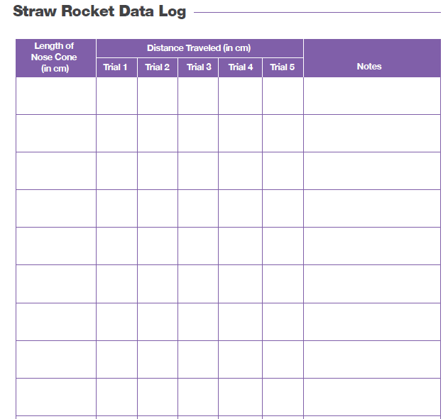
Record the distance in the data log:
Activity 3- Dragon Rocket Quiz Log on to teams, go to your SCI channel, open the ASSIGNMENT tab. Click on the Dragon Rocket quiz- try it and see how much you learned.

